Student Name
Instrument(s)

Dr. Name, piano

Work ……………………………………………............................ Composer
Movement (composer dates)
Movement
Movement
Movement

Work ……………………………………………............................ Composer
(composer dates)

Work ……………………………………………............................ Composer
(composer dates)
arr. Arranger

Work ……………………………………………............................ Composer
I. Movement (composer dates)
III. Movement
XI. Movement

Work ……………………………………………............................ Composer
(composer dates)
with Guest, instrument

Audience members are reminded to silence all electronic devices before the performance.

UPCOMING EVENTS

www.vandercook.edu/events

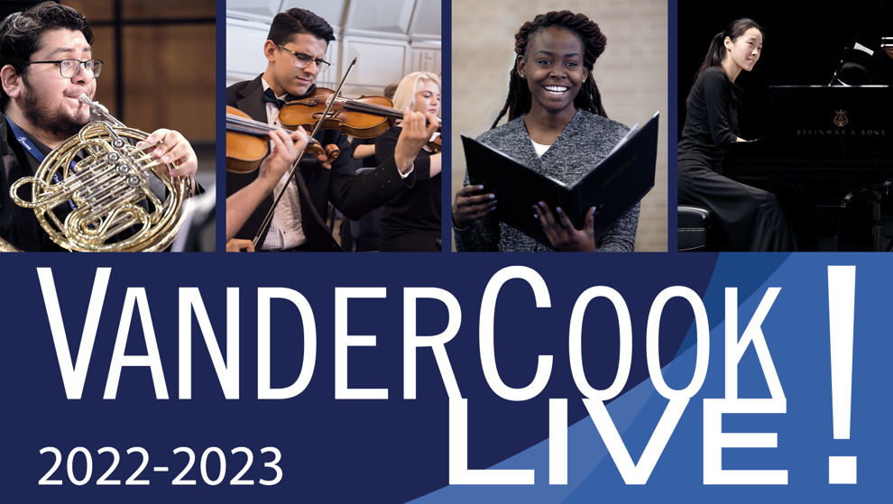

Recitalist
Instrument(s)
Junior/Senior Recital

Month Date, Year
Time p.m.

VanderCook College of Music
George A. Quinlan Hall
3125 South Federal Street, Chicago

This recital is presented in partial fulfillment of the requirements for the
Bachelor of Music Education degree

